MediLink
AI-Powered Clinical Intelligence Platform

Hackathon Project Documentation

Team Name:
Baito Bytes

Team Members:
Maha Mateen
Madiha Aijaz
Maryam Masooma
Qazi Isra
Tamana Zehra

Date:
14-07-2026

Table of Contents
Table of Contents 1
1. Project Overview 2
2. Problem Statement 3
3. Proposed Solution: The MediLink Ecosystem 4
4. Objectives 5
5. Target Users 6
5.1 Primary Users 6
5.2 Secondary Users 6
6. Competitive Analysis 7
6.1 Existing Solutions 7
6.2 How MediLink Differs 7
7. MVP Features 8
8. User Journey 9
8.1 Doctor Journey 9
8.2 Patient Journey 10
9. SYSTEM ARCHITECTURE 11
10. AI Workflow 12
11. Technology Stack 13
13. Future Roadmap 15
14. Project Images

1. Project Overview
Healthcare providers often make treatment decisions using incomplete or fragmented patient information. Medical records are frequently scattered across hospitals, clinics, laboratories, and paper prescriptions, making it difficult for doctors to obtain a complete view of a patient's medical history during consultations.
MediLink AI is an AI-powered Clinical Intelligence Platform designed to organize patient health records into a single chronological timeline and generate concise clinical summaries. Rather than replacing existing digital health systems, MediLink AI complements them by helping healthcare professionals access essential patient information quickly, leading to more informed and efficient clinical decision-making.

2. Problem Statement
Healthcare providers often make treatment decisions with incomplete patient information. Many patients unintentionally forget to mention important details such as ongoing medications, allergies, chronic illnesses, previous surgeries, or recently completed antibiotic courses. This challenge becomes even more severe when patients consult multiple doctors or travel to different regions, where communication barriers and disconnected healthcare records make accurate history-taking difficult.
As Kashmiris, we have personally observed another common healthcare challenge within our own families. Even for minor illnesses such as coughs, colds, or seasonal infections, it is common for patients to consult multiple doctors before deciding on a course of treatment. Since each consultation happens independently, doctors often have no visibility into medications that have already been prescribed. This can lead to duplicate prescriptions, repeated antibiotic use, potential drug interactions, unnecessary diagnostic tests, and inconsistent treatment plans. These real-life experiences became one of the primary motivations behind our project.
Patients with chronic conditions such as diabetes, hypertension, kidney disease, heart disease, or drug allergies may also unintentionally omit these details during consultation. Without access to a complete medical history, doctors may prescribe medicines that are less effective, potentially unsafe, or interact with existing medications.
In Kashmir, there is currently no patient-centric system that enables healthcare professionals to securely access a patient's essential medical history across different hospitals and clinics with the patient's explicit consent. This leads to fragmented healthcare, delayed diagnosis, duplicate diagnostic tests, medication errors, unnecessary prescriptions, and avoidable health risks.
Although India has taken significant steps toward digital healthcare through initiatives such as the Ayushman Bharat Digital Mission (ABDM) and ABHA, access to patient information may still remain fragmented across hospitals, clinics, laboratories, and paper records depending on adoption and availability. As a result, doctors often spend valuable consultation time reviewing scattered reports instead of focusing on patient care.
These challenges highlight the need for an intelligent, patient-centric platform that organizes medical records into meaningful clinical insights while supporting existing digital health ecosystems.

3. Proposed Solution: The MediLink Ecosystem

MediLink AI – An Intelligent Clinical Intelligence Platform

MediLink AI is an AI-powered Clinical Intelligence Platform designed to complement existing digital health ecosystems rather than replace them. The platform consolidates a patient's essential medical information into a unified, chronological health profile and generates concise AI-assisted clinical summaries that help doctors quickly understand the patient's medical history during consultations.

For the hackathon MVP, MediLink securely stores patient records using a clinic-generated Patient ID, while keeping the architecture ready for future integration with ABHA . Access to patient information is permission-based, ensuring that only authorized healthcare providers can view medical records with the patient's consent.

Key Components of the Solution

Unified Patient Health Profile

Patient information—including diagnoses, medications, allergies, laboratory reports, surgeries, and treatment history—is organized into a single chronological timeline, giving doctors a complete view of the patient's healthcare journey.

AI-Powered Clinical Summary

Instead of manually reviewing multiple reports, doctors receive a concise AI-generated summary highlighting chronic conditions, current medications, allergies, previous treatments, and other clinically relevant information. The AI assists healthcare professionals by presenting important information quickly but does not replace clinical judgment.

Consent-Based Access

Patients remain in control of their medical records. Healthcare providers can access patient information only after appropriate authorization, ensuring privacy and responsible use of health data.

Improved Clinical Workflow

By reducing the time required to review fragmented records, MediLink enables doctors to spend more time interacting with patients and making informed clinical decisions while reducing duplicate prescriptions, repeated investigations, and medication errors.

Scalable Foundation

The MVP has been designed with future expansion in mind. The architecture supports integration with digital health platforms such as ABHA , diagnostic laboratories, pharmacies, and additional AI-powered clinical decision support features.

4. Objectives
Project Objectives:
- Enable doctors to quickly access a patient's essential medical history.

- Reduce the time spent reviewing fragmented medical records.

- Improve clinical decision-making through AI-generated clinical summaries.

- Minimize duplicate tests, repeated prescriptions, and medication errors.

- Demonstrate a practical AI-assisted clinical intelligence platform that complements existing digital health ecosystems.

5. Target Users

5.1 Primary Users
User | Description
🩺Doctors | Use the platform to search patients, review medical history, receive AI-generated summaries, and support clinical decision-making.
🧑‍🦳Patients | Access their health records, upload medical reports, and share relevant information with healthcare providers.

5.2 Secondary Users
User | Description
🤵Administrators | Manage user accounts, oversee patient records, and support clinic operations if administrative functionality is included in future versions

6. Competitive Analysis

6.1 Existing Solutions

India has made significant progress toward digital healthcare through initiatives such as the Ayushman Bharat Digital Mission (ABDM), ABHA, and digital health record platforms. These initiatives focus on enabling secure health data exchange and improving interoperability between healthcare providers. However, during routine clinical consultations, doctors may still need to review multiple records from different sources and manually identify the most relevant information. This can be time-consuming, especially in busy clinical environments.

6.2 How MediLink Differs
Feature | Existing Digital Health Systems | MediLink
Primary Purpose | Store, identify, and exchange health records | Organize records into clinically useful insights
AI Clinical Summary | No integrated AI summarization | AI-generated clinical summary for doctors
Medical Timeline | Records may come from multiple sources | Unified chronological patient timeline
Clinical Decision Support | Limited | Highlights allergies, medications, chronic conditions, and recent treatments
Role in Healthcare | Digital health infrastructure | AI-assisted layer that complements existing infrastructure

7. MVP Features

Feature | Description
Authentication | Admin authenticate’s doctor’s using their state registration id.  Patients get authenticated using their unique ABHA id.
Admin Management | Admin can manage doctors of his hospital.
Doctor Dashboard | The doctor is able to view and add the patient's medical details.  Search patients using Patient ID or ABHA ID.
Patient Dashboard | Patients are able to access and upload their medical records.
AI summary | Generate a concise summary of the patient's medical history.
Reports & Prescriptions | View uploaded reports and prescriptions
Medical Report | Display health events chronologically.

8. User Journey

8.1 Doctor Journey

Doctor Login
Search Patient
View Patient Profile
Read AI Clinical Summary
View Medical Record
Open/View Reports/Prescriptions
Finalizes Treatment Plan

8.2 Patient Journey
Patient Login
View Personal Profile
View Medical History
Upload Medical Records
Share Records with Doctor

9. SYSTEM ARCHITECTURE
The MediLink AI system follows a layered architecture that separates the user interface, backend services, database, and AI processing module. This modular design improves maintainability, scalability, and security while allowing future integration with national digital health initiatives such as ABHA .

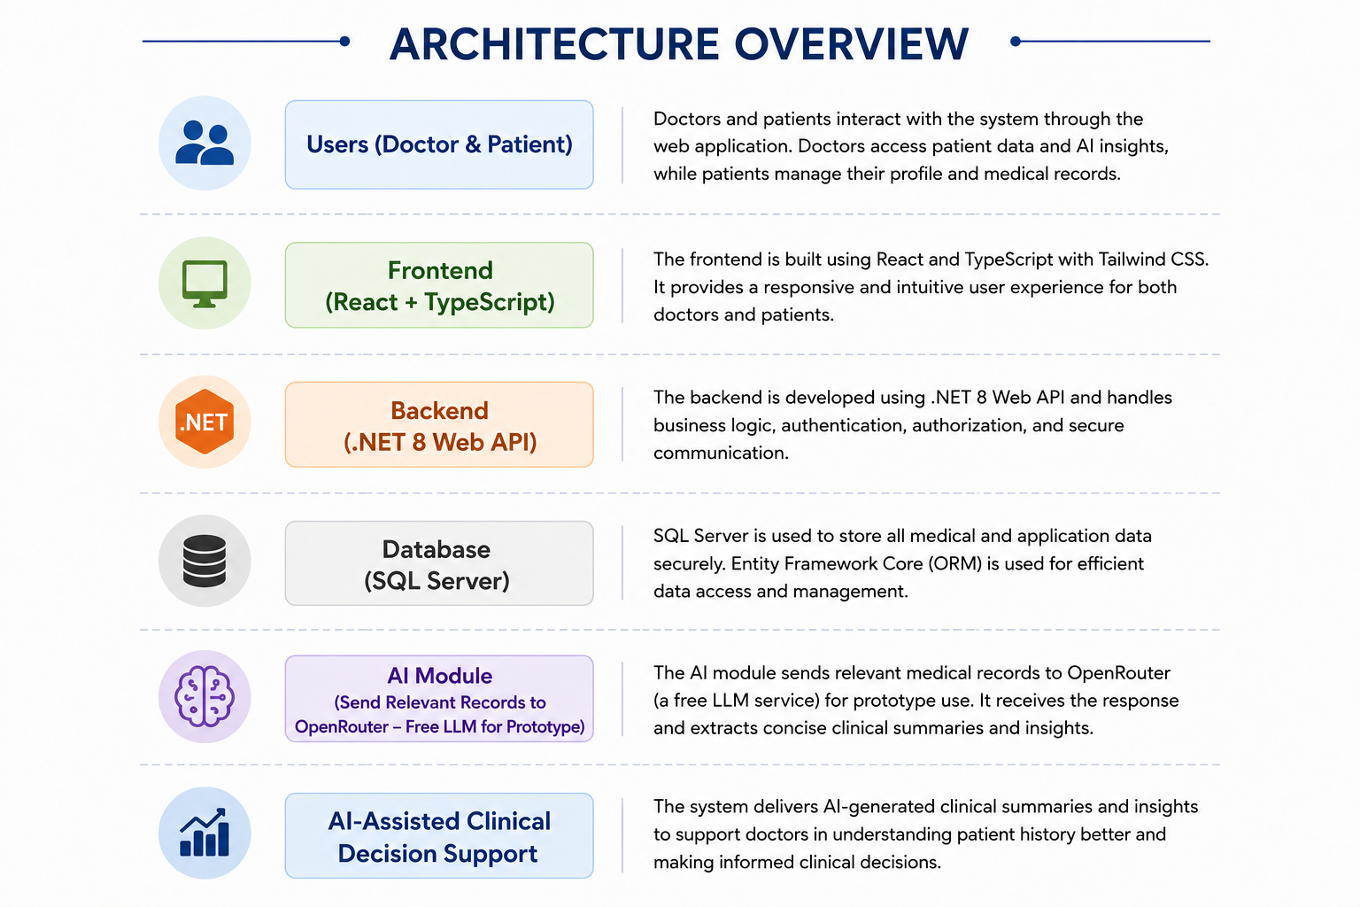

10. AI- WORKFLOW

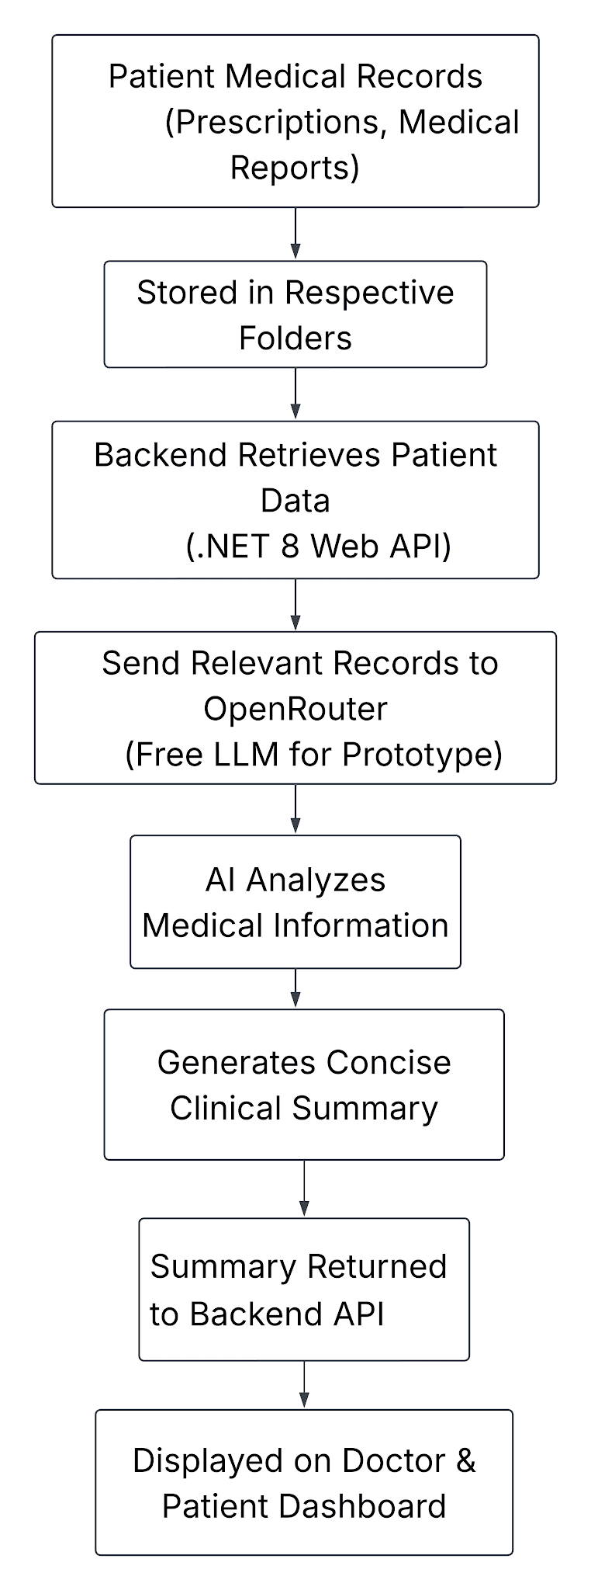

11. Technology Stack
MediLink AI is built using a modern full-stack technology stack that enables rapid development, secure data management, and AI-assisted clinical summarization. The selected technologies support a scalable architecture while remaining lightweight for the hackathon MVP.
Category | Technology | Purpose
Frontend Framework | React.js (v19) | Builds the Single Page Application (SPA) and manages the user interface
Programming Language | TypeScript | Provides type safety and improves code maintainability.
Build Tool | Vite(V8) | Enables fast development, hot module replacement, and optimized production builds.
UI Styling | Tailwind CSS (v4) | Creates a responsive and consistent user interface using utility-first CSS.
Icons | Lucide React | Provides lightweight and consistent medical and action icons.
Routing | React Router DOM (v7) | Manages client-side navigation between application pages.
Backend Framework | .NET 8 Web API | Handles business logic, API endpoints, authentication, and communication with the frontend.
Authentication | ASP.NET Identity | Provides secure user authentication and role-based access control.
Database | SQL Server | Stores patient records, prescriptions, reports, and user information securely.
ORM | Entity Framework Core | Simplifies database operations through object-relational mapping.
Ai Integration | OpenRouter (Free LLM) | Generates AI-powered summaries of patient medical records for the hackathon prototype.
Version Control | Git & GitHub | Supports collaborative development, version tracking, and source code management.

12. Future Roadmap
The following strategic enhancements are planned to further advance the platform’s capabilities within the healthcare ecosystem:
- Establish nationwide interoperability through seamless integration with ABHA and the ABDM framework.
- Implement OCR technology to enable automated data extraction from handwritten medical notes and physical reports.
- Expand the ecosystem by connecting clinical networks, diagnostic centers, and pharmaceutical providers.
- Deploy AI-driven safety features, including automated alerts for drug-to-drug interactions and known patient allergies.
- Enhance accessibility for diverse users through the introduction of multilingual interface support.
- Develop a dedicated mobile application to provide patients with convenient, on-the-go access to their health profiles.
- Transition to a secure cloud-based infrastructure to ensure high availability and regional scalability.

